

Delivery Time

Magento module slider range delivery time for products



Table of Contents
I Requirements 3
II Installation 3
Module 3
III Usage 3
1) Config 3
2) Product edit page 4
3) Pages 6
IV Dev notes 9
1) Elasticsearch 9
2) Theme 9
3) Log files 9

I Requirements
- PHP >= 7.1
- Magento >= 2.3

II Installation

Module
php bin/magento module:enable Greenrivers_DeliveryTime
php bin/magento setup:upgrade
php bin/magento setup:di:compile
php bin/magento setup:static-content:deploy -f

III Usage

1) Config
Stores → Configuration → GREENRIVERS → Delivery Time
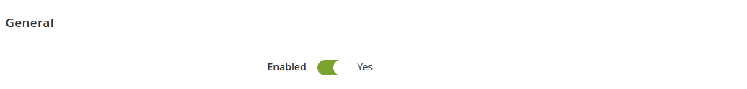
General → Enabled - module activation

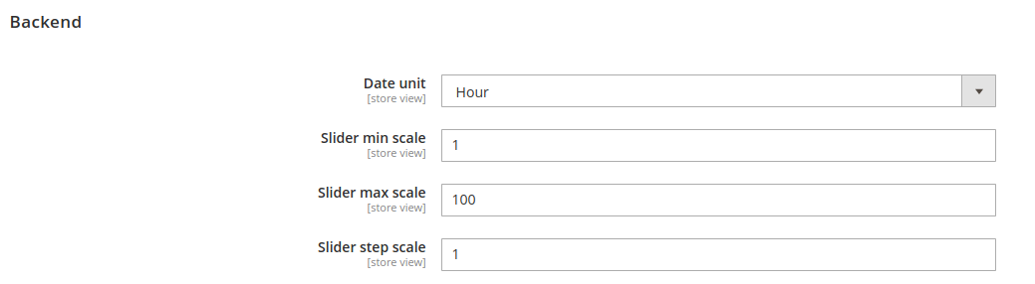
Backend → Date unit – choose unit which display on slider and delivery time in frontend
Backend → Slider min scale – minimum slider value
Backend → Slider max scale – maximum slider value
Backend → Slider step scale – slider step
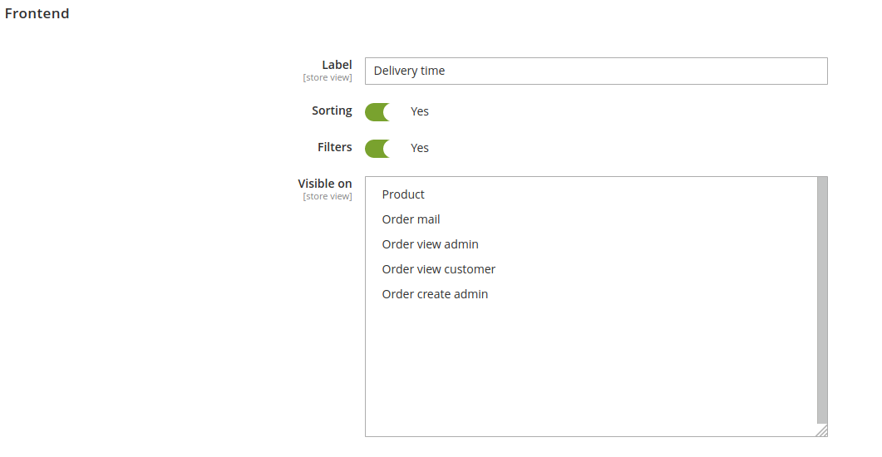
Frontend → Label – set text, which display on frontend
Frontend → Sorting – enable if You want to add sort by option on category page
Frontend → Filters – enable if You want to add filter by delivery time option on category page
Frontend → Visible on – select which pages should display delivery time

2) Product edit page
Catalog → Products
Simple product
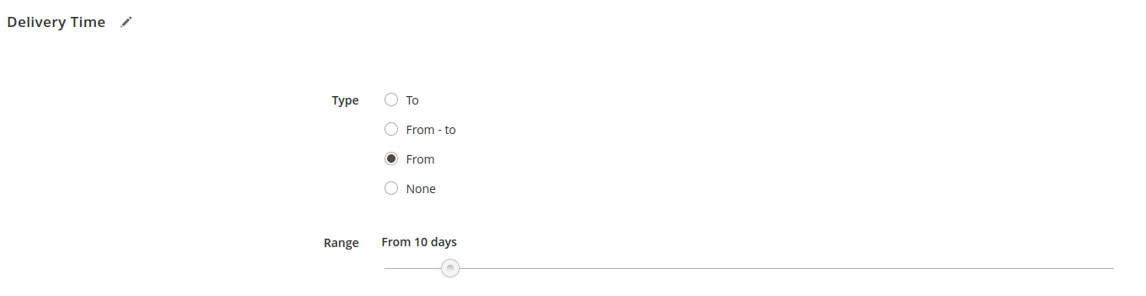
In Delivery Time tab select one from 4 types and set up value on slider.

Configurable product
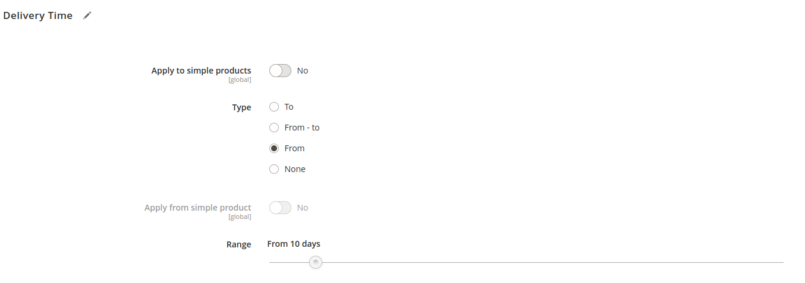
There are two additional options:
Apply to simple products – all child products inherit value from configurable
Apply from simple product – choose value from child products on select list (enable since all children have set delivery time)

3) Pages
Category

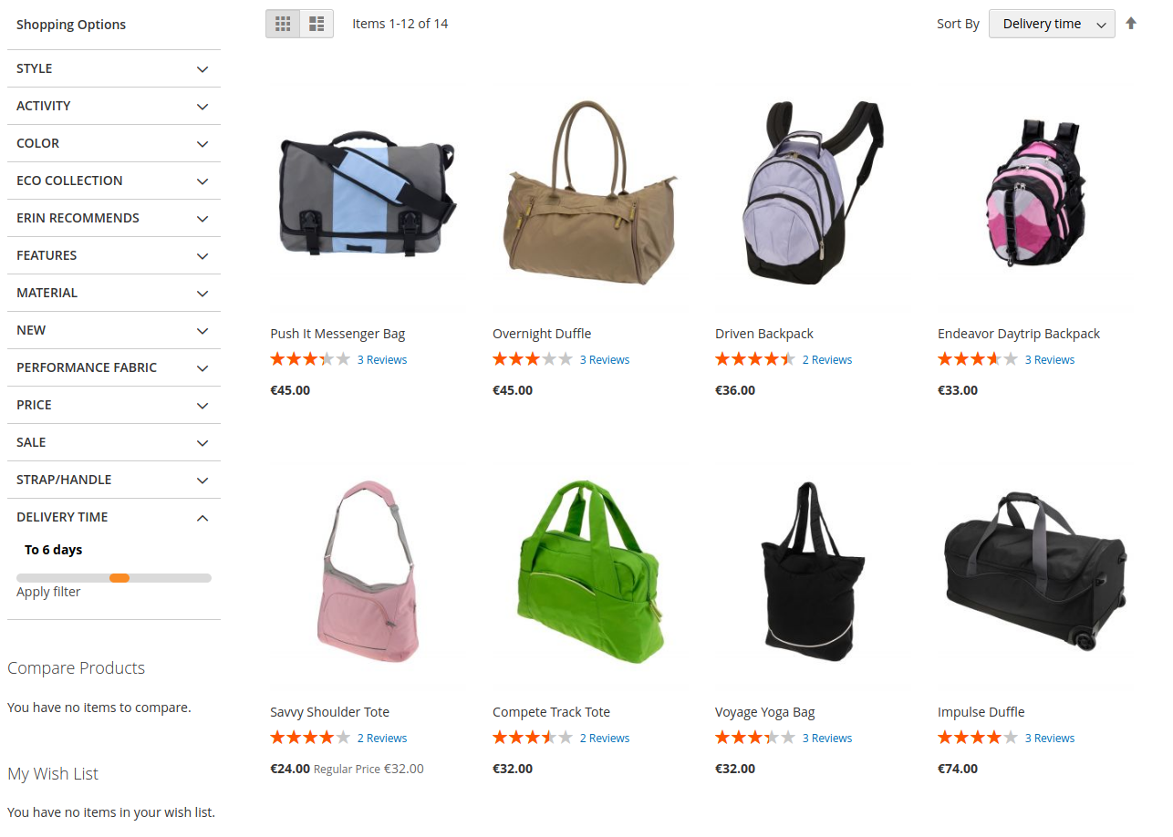
Depend on enable/disable options new filter (by slider range) and sort by option should be visible.

Product

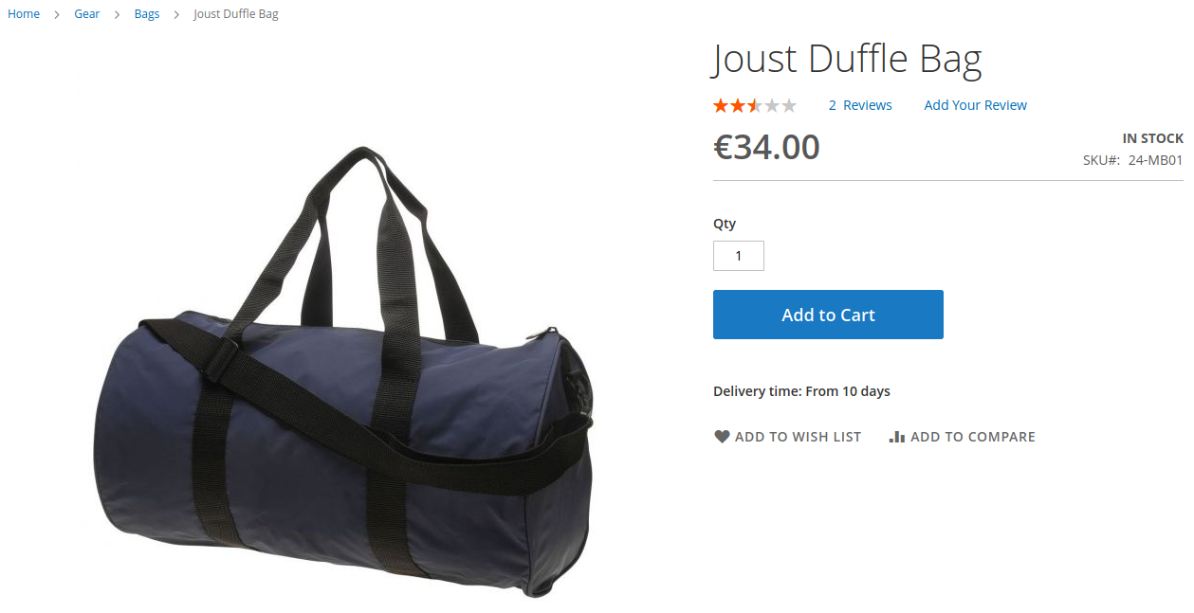
If product page has been selected from visible on multiselect, delivery time should be show below Add to Cart button.

Order mail

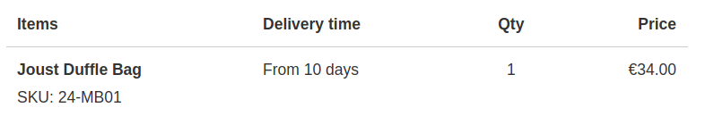
New column to order confirmation mail has been added after select page from visible options.

Order view admin (Sales → Orders)

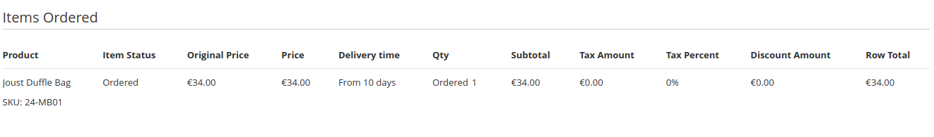
New column to order admin summary view should be visible if page has been selected in frontend config.

Order view customer (My Account → My Orders → View Order)

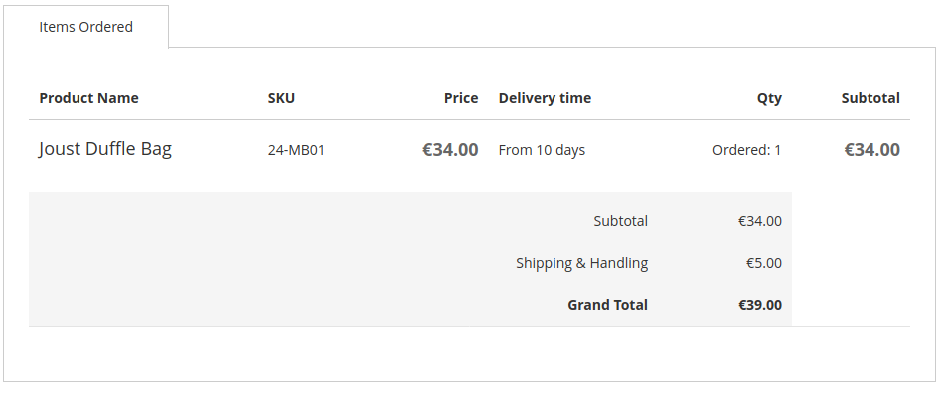
Select this page from visible config if You want to show delivery time in order view for customer.

Order create admin (Sales → Orders → Create New Order)

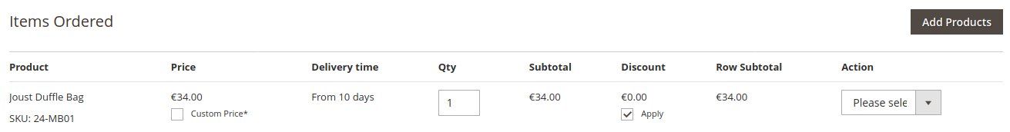
New column added to order create page after selected this option from configuration.

IV Dev notes

1) Elasticsearch
Sort option works for Magento version 2.3.* with disabled Elasticsearch.
Sort option not available for Magento version 2.4.*.

2) Theme
Due to override templates from default Magento Theme Luma, this extension may not working properly with external themes.

3) Log files
Errors are logged in var/log/greenrivers/delivery_time.log file.

